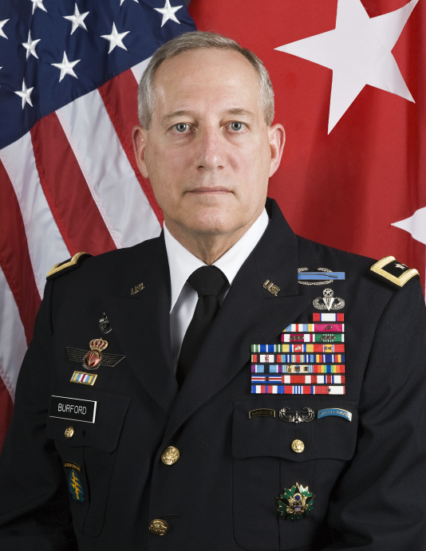

David P. Burford (Dave)

Major General (retired)
Alabama Army National Guard

Retired after 40⁺ years
Southern Nuclear Operating Company

Dave Burford retired in July 2018 from Southern Nuclear in Birmingham after 40 years,
working in several of Southern Company’s subsidiaries. Previously with Southern Nuclear, Dave has been the Acting Director of Fleet Security and Manager of Cyber Security. In earlier assignments with Southern Company, Dave spent two years as a registered federal lobbyist in Washington, followed by assignments leading environmental research projects for which he received industry awards for his leadership such as the PowerPlant Project of the Year; Air Quality Project of the Year and the Composite’s Institute Design Award of Excellence. Dave is also a past advisor to the Electric Power Research Institute, a speaker at the Washington Coal Club and a graduate of both Harvard University and George Washington University’s Senior Executive Program. He has served as Chairman of the Nuclear Sector Coordinating Council in Washington DC and is formerly Chairman Emeritus of the Board of Directors for Three Hots and a Cot; a 501(c)(3) non-profit organization that provides shelter for homeless veterans in Birmingham.

Dave entered the service as part of Georgia Tech’s Army ROTC program, graduating as a Distinguished Military Graduate with a degree in Chemical Engineering. Dave spent five years on active duty immediately after college before joining the Alabama National Guard in order to gain a slot to go to the Army’s Special Forces school where he was awarded his Green Beret as a Captain in 1984.

On the early morning hours of 9/11, 2001; Dave was in a watermelon field near Tampa, buying the land for a prospective Southern Company gas turbine generating station, when a cell phone call from Fort Bragg made Dave one of the first people mobilized for the War on Terrorism; Dave reported in as the Deputy Commanding General of Army Special Forces, serving almost three years of active duty, including time as the Acting Commanding General of the Army’s 9,000 man Green Beret force in the early stages of Operation Enduring Freedom.

He deployed to Afghanistan in the first 100 days of the war, working with Army, Navy and Air Force Special Operations Forces and other governmental agencies in that distant battlefield.

Dave’s military interest was strongly influenced by his father, 2LT Macon C. Pippen, who was also an Alabamian, a Georgia Tech Army ROTC graduate and a World War II combat infantry veteran with the 10th Mountain Division in Italy. 2LT M.C. Pippen was severely wounded there and he later succumbed to these wounds early in Dave’s life. Dave’s late Father-in-law; Private Joseph Verrastro, is also a World War II combat infantry veteran and a survivor of the Battle of the Bulge.

As an Alabama Guardsman for almost thirty years, Dave has rescued flood victims, reported for duty during tornados, provided protection and shelter for abused women & children during ice storms, walked the halls of the Pentagon, testified before Congress, met with President George Bush & Afghanistan’s President Karzai, eaten dinner at Vice President Biden’s home and met with the US Ambassadors to Kenya, Ethiopia and Djibouti at their Embassies abroad. In the Fall of 2010, he was again in uniform in the White House Situation Room with President Obama’s National Security staff, representing the Pentagon, on a Presidential Level Exercise (PLE) focused on a domestic nuclear power plant scenario.

In February of 2011 after almost thirty-eight years in uniform, Dave retired as a Major General. His last duty assignment was for four years as Deputy Commander of the US Special Operations Command at MacDill Air Force Base in Tampa where he directed all the reserve component special operations forces within the Department of Defense; Rangers, SEALs and Green Berets. He also served concurrently as Special Assistant to the Chief of the National Guard Bureau in the Pentagon. When he retired in 2011, Dave was the highest ranking Green Beret in the Army’s reserve components. At the 2012 Compass Bowl in Birmingham, he was named Alabama’s Distinguished Military Veteran of the Year.

General Burford’s military awards and decorations include the Army’s Distinguished Service Medal, the Department of Defense Superior Service Medal, the State of Florida’s Distinguished Service Medal, the Army Ranger tab, the Army Special Forces tab, the Master Parachutists badge, the Combat Infantryman’s Badge, the General John J. Pershing Award and foreign awards from the governments of Germany and Spain.

